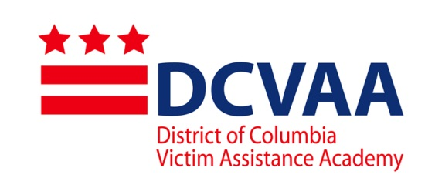

Mass Disaster Training

2015 Student Application

(Type or print clearly)

First Name: _________________________________Last Name: _________________________________

Organization: _______________________________________________________________________

Work Address: ______________________________________________________________________

Work Phone: _______________________ Fax #: ________________________________

Email: ___________________________________________

Current Job title: ______________________________________________ Paid _____ or Volunteer_____

Number of years of direct victim service _________ From: _________________ To: ______________

Education/Degree(s): ______________________________ Major: _____________

1. Select the single category that best describes the type of organization you represent.

Criminal Justice Community Nonprofit Additional Organizations
_ Police-based _ Homicide _ Faith-based
_ Court-based _ Domestic Violence _ Hospital/Medical
_ Corrections-based _ Sexual Violence _ Media
_ Military-based _ Child Abuse _ Government (please list)
_ Juvenile-based _ Stalking _Other (please list)
_ Other: (please list) _ Property Crime
_ Economic
_ Other: (please list)

2. Please indicate the types of victims you primarily serve.

_ Assault/Robbery _ Immigrant Populations _Victims with Physical Disabilities
_ Child Abuse _ Property Crime _ Victims with Mental Disabilities
_ Domestic Violence _ Economic / Fraud _ Other: (please list)
_ Drunk Driving _Sexual Assault
_ Elderly Victims _Teens and Adolescents
_ LGBTQ _ Trafficking

3. Please indicate the types of services you primarily provide for crime victims in your current position. (Check no more than five boxes)

_ 24-Hour Hotline _ Information/Referral _ Shelter
_ Child Care _ Legal/Civil Advocacy _ Short-Term Counseling
_Comp. Claim Assistance _ Long-Term Counseling _ Victim Impact Statement
_ Court Accompaniment _ Medical Advocacy _ Other: (please list)
_ Criminal/Juv. System Advocacy _ Notification
_ Crisis Intervention _ Restitution Assistance

4. Briefly summarize your current or previous experience assisting emergency victims in the last three years. Provide position, responsibilities and dates of service from most recent to past.

Position: From: To:
Organization:
Responsibilities:

Commitment Statement
5. Successful applicants must commit to the entire 13-hour (2-day) training. Tuition is included at no cost. Meals are not included. Attendees must make their own travel arrangements. Please signify your commitment to complete the full 13-hour (2-day) training.

______________________________________________________________________________________
Applicant print name and sign Date

______________________________________________________
**Supervisor print name and sign Date

** Supervisor’s signature consents to applicant’s participation of 13 hours of DCVAA required attendance during regular work hours.
**Supervisor’s support for the Academy consents to long-term case management and advocacy for the mass disaster victims served at the Family Assistance Center.

The application deadline is October 15, 2015. Signed applications and attachments may be emailed in PDF format to OVS@dc.gov:

DC Victim Assistance Academy
Office of Victim Services and Justice Grants
441 4th Street NW #727N
Washington, DC 20001

