GOVERNMENT OF THE DISTRICT OF COLUMBIA  Executive Office of the Mayor  OFFICE OF VICTIM SERVICES AND JUSTICE GRANTS  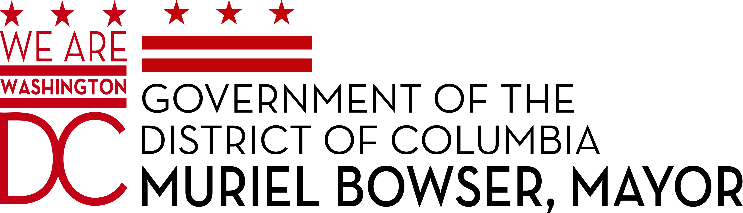  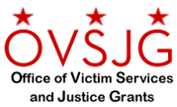  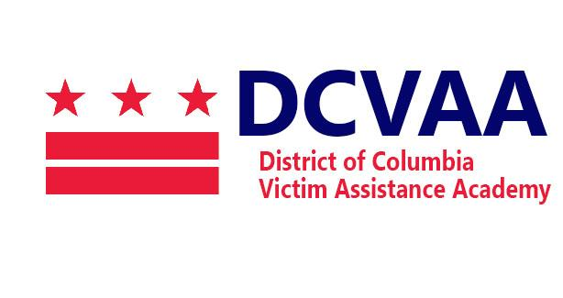  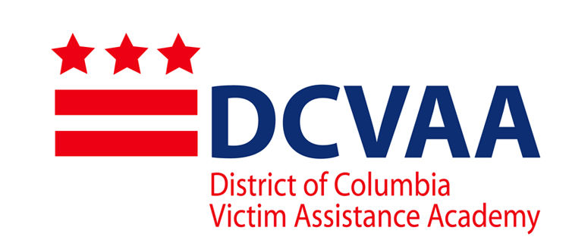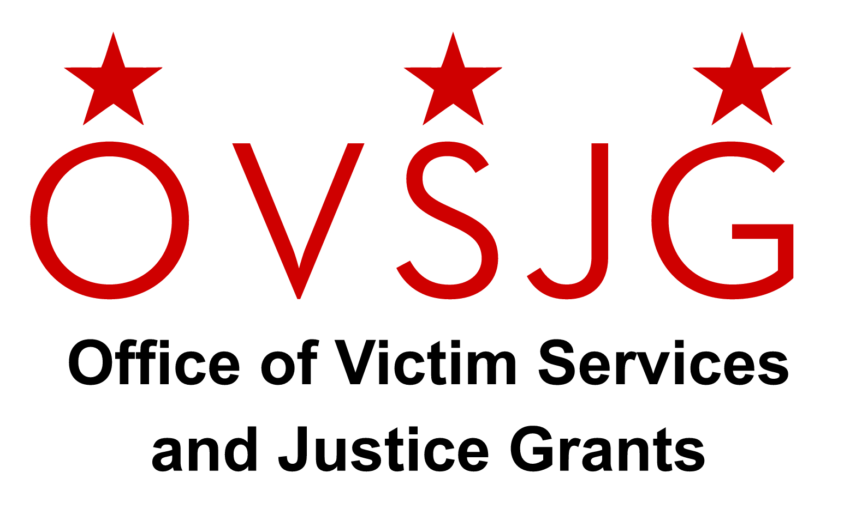  Save the DAte  DC Victim Assistance Academy Training  The DC Victim Assistance Academy (DCVAA), sponsored by the DC Office of Victim Services and Justice Grants, is designed to empower and motivate victim service providers and allied professionals through quality education that results in services and support for all victims of crime that are consistent, collaborative, and culturally competent.  Registration Coming Soon  For more information, email the DCVAA coordinator at ovsjg@dc.gov and visit www.ovsjg.dc.gov. | Confirmed Dates  Mass Disaster Orientation February 27, March 20, or March 27  Mass Disaster Two-Day Training February 28 - March 1 March 21- March 22 March 28 - March 29  Confidentiality Webinar Training March 8  Elder Abuse Training June 19  Program Development and Building a Culture of Self-Care June 26  Upcoming Dates  Motivational Interviewing and Somatic Methods with Victims of Crime April  Cultural Competency September

